The Study on the Weighting Matrix for Electrical Capacitance Tomography

Ji-Hoon Kim¹ and In-Soo Lee¹

¹ School of Electronics Engineering, Kyungpook National University
Daegu, 41566, Korea
insoolee@knu.ac.kr

Abstract

For the image reconstruction in electrical capacitance tomography (ECT), most of the proposed algorithms use the sensitive matrix. However, because of the non-linearity and ill-posedness of the ECT problem, the reconstructed image is inadequate. The weighting matrix is defined based on the distance between the centre of mesh and adjacent paths. The proposed method based on modified weighting matrix can obtain more good quality image than sensitivity matrix based conventional method.

Keywords- electrical capacitance tomography, weighting matrix and image reconstruction

I. Introduction

Electrical capacitance tomography (ECT) is to acquire the images of the distribution of the dielectric materials within the domain of interest. This image is obtained by the image reconstruction algorithm from measured capacitance at the electrodes placed on the boundary the domain. By comparison, the hardware cost of ECT is low and the reconstruction time to obtain the results is short. It has also the advantage of the portability. However, the spatial resolution of the image has a low clarity as a shortcoming. The main application is in the industrial areas[1-4].
During this period, there are a lot of proposals about the image reconstruction in ECT, such as the linear back-projection (LBP), the Tikhonov regularization method, the algebraic reconstruction technique (ART), the Landweber iteration method, the soft-thresholding iteration method, the directional algebraic reconstruction technique (DART) and so on[2,5-8]. These imaging techniques distinguish between non-iterative and iterative methods. The non-iteration method has the features of the simple structured and the short time reconstuction[2]. However, the non-linearity and the ill-posedness of the ECT will lead to the difficulty of the non-iteration to obtain satisfactory images. In order to solve these problems, a variety of iteration methods have been developed. Compared to the non-iteration method, to use iteration method can achieve enhanced images but the large computations are responsible for using only off-line.
Most of the image reconstruction algorithms for ECT are using sensitive matrices. However, the reconstructed image by using sensitive matrix is still insufficient. In this paper, the image reconstruction performance can be improved by using the modified weighted matrix instead of the sensitive matrix in the conventional algorithm for ECT. We carried out the computer simulations to confirm the suitability of the proposed method through a variety of internal permittivity distribution scenarios.

II. Modified Weighting Matrix

This chapter is about the sensitivity matrix and the weighting matrix which show the relationship between measured capacitance and permittivity distribution inside the ECT sensor. And we briefly introduce the LBP algorithm used in ECT

A. The Sensitivity Matrix

The relationship between the internal permittivity distribution and the measured capacitance in the electrode is nonlinear. But if the difference between the dielectric constant constituting the internal substance is small, a simple linear approximation can be expressed as follows:

$C=Sε$ (1)

where $C∈ℜ^{N×1}$ is the capacitance vector, $S∈ℜ^{N×M}$ is the sensitive matrix, $ε∈ℜ^{M×1}$ is the permittivity vector, and $M$ is the number of all elements in the domain. $N$ is the number of independent measurements. In the sensitive matrix $S$, the factor of $S$ is defined as follows:

$S_{\text{SD}}(k)=\frac{C_{\text{SD}}(ε_{h}(k))−C_{\text{SD}}(l)}{ε_{h}−ε_{l}}\frac{A_{\text{max}}}{A_{k}}$ (2)

where $S_{\text{SD}}(k)$ means the $k$-th factor of the sensitive matrix between a source and a sensed electrode. $ε_{h}$ and $ε_{l}$ are the high capacitance value and low capacitance value respectively. $C_{\text{SD}}(ε_{h}(k))$ means, when the capacitance of the $k$-th element is $ε_{h}$ and the rest are $ε_{l}$, the capacitance between the source and the detection electrode. $C_{\text{SD}}(l)$ shows the capacitance between the source and the detection electrode when the sensor interior is fulfilled with $ε_{l}$. $A_{k}$ and $A_{\text{max}}$ are the $k$-th element and the maximum element area respectively [3]. For normalizing (1), the normalized sensitive matrix $S^{}$, the normalized permittivity $g^{}$ and the normalized capacitance $C^{}$ are shown as follows:

$S^{}=\frac{S_{\text{SD}}}{\sum{S_{\text{SD},k}}}$, $g^{}=\frac{ε−ε_{l}}{ε_{h}−ε_{l}}$, $C^{}=\frac{C−C_{l}}{C_{h}−C_{l}}$ (3)

where $\sum{S_{k}^{}}=1$, $C$ is the measured capacitance vector. $C_{h}$ and $C_{l}$ are the capacitance when domain is fulfilled with medium of $ε_{h}$ and $ε_{l}$ respectively[9]. From (3), (1) can be used as follows:

$C^{}=S^{}ε^{}$. (4)

According to the general notation, the asterisk (*) of (4) are going to neglect next chapter.

B. The Weighting Matrix

To obtain the weighing matrix, the electrical field centre line (EFCL) each between electrodes is used as line each between electrodes. The EFCL between electrodes is to approximate as apart of circle on the centre line of the existing electrical field based on the assumption that the sensor is circular and has homogeneous permittivity. For an $L$-electrode sensor, the total number of EFCLs is $N=L(L−1)/2$, which is the same number as independent measurements. EFCLs were sorted the groups with $(L−1)$ or $L$ EFCLs in the $L$ direction.
The backward-weighting matrix $W_{i}^{B}$ and the forward- weighting matrix $W_{i}^{F}$ in $i$-th direction relates EFCLs in $i$-th direction and all elements in the sensor. And its defined as

$g=W_{i}^{B}C_{i}$, $C_{i}=W_{i}^{F}g$, $W_{i}^{F}={\left[W_{i}^{B}\right]}^{T}$ (5)

where $g$is the normalized permittivity vector. $C_{i}$ is the normalized capacitance vector in the $i$-th direction, and $T$is transpose.
The weighting between the $j$-th and $(j+1)$-th EFCL in the $k$-th direction and the $i$-th element is defined as follows:

$W_{k}^{B}(i,j)=\frac{d_{2}}{d_{1}+d_{2}}$, $W_{k}^{B}(i,j+1)=\frac{d_{1}}{d_{1}+d_{2}}$, (6)
$i=1,2,⋯,M$, $j=1,2,⋯,N_{d}$, $k=1,2,⋯,L$

where $M$ is the number of the element in the sensor and $N_{d}$ is the number of the EFCL in a direction, assuming that the EFCL and the elements outside the EFCLs $L_{1}$ and $L_{N_{d}}$ are only affected by EFCLs $L_{1}$ and $L_{N_{d}}$ [5].

C. Modified Weighting Matrix

The weighting matrix defined earlier is not directly applicable to the existing algorithms for ECT. To apply the weighting matrix to the existing algorithms, the $L$ forward-weighting matrices must be augmented as follows:

$W=\left[\begin{matrix}W_{1}^{F} \\ W_{2}^{F} \\ ⋮ \\ W_{L}^{F}\end{matrix}\right]∈ℜ^{N×M}$ (7)

where $W_{i}^{F}$ is the front weighting matrix in the $i$-th direction.

D. Linear Back-Projection

The LBP is the original method used to reconstruct ECT images[3]. If $S$ is considered to be a linear mapping from the normalized permittivity vector to the normalized capacitance vector, $S^{T}$ can be considered as a related mapping from the normalized capacitance vector to the normalized permittivity vector, giving an approximated solution

$\hat{g}=S^{T}C$ (8)

where $\hat{g}$ is the solution of the mathematical electrode for (4). Although it is not quite accurate by mathematics, the LBP algorithm, because of its simplicity, is widely used for on-line image reconstruction. However, the quality of the restored image by LBP is low, so it can only provide qualitative information.

III. Computer Simulations

In order to verify the performance of the modified weighting matrix, a variety of scenario simulations were carried out.

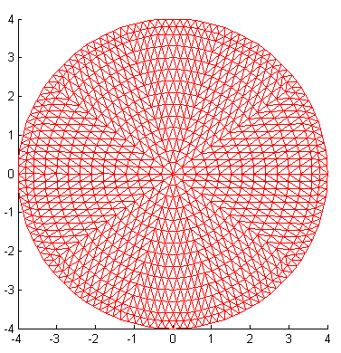

Fig. 1 Used mesh

In order that the image reconstruction looks like Fig. 1, we uses the ECT sensor with 1039 nodes and 1948 triangular mesh ($M=\text{1948}$ ). The diameter of ECT sensor is 8cm and the number of electrode is 16 ($L=\text{16}$).

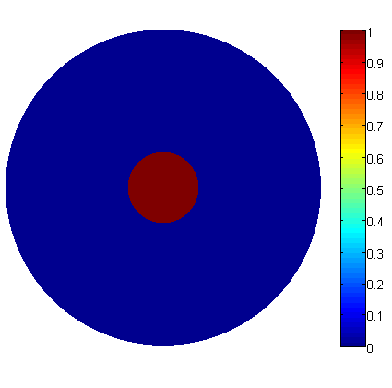 | 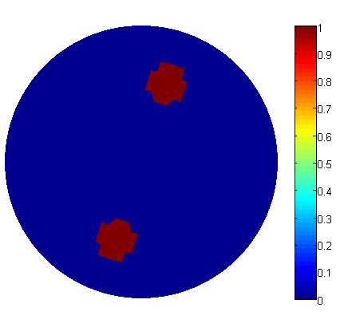
(a) case 1 | (b) case 2
Fig. 2 Used mesh and original images

In order to evaluate the reconstruction performance of our proposal, as shown in Fig. 2, we simulate two different permittivity distributions. Case 1 is that a waterdrop exists at the middle of the domain containing air. Case 2 is that two waterdrops exists near the boundary of the domain. In the Fig. 2, The low and high permittivity materials were air (1) and weter (80), respectively.

 | LBP_s | LBP_w
case 1 | 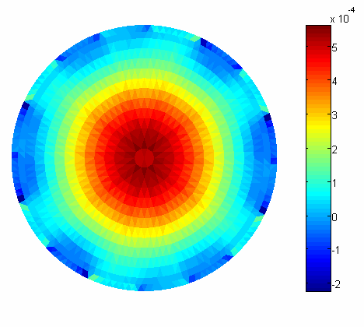 | 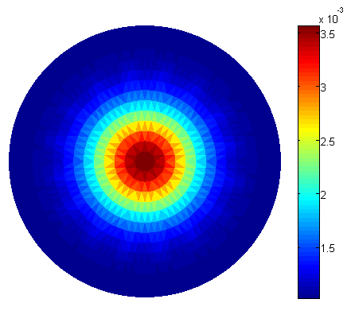
case 2 | 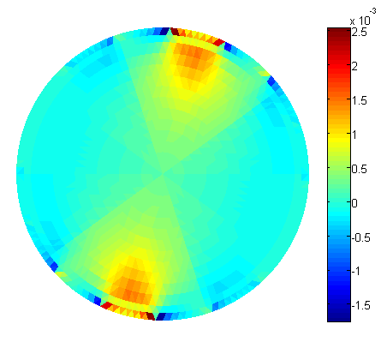 | 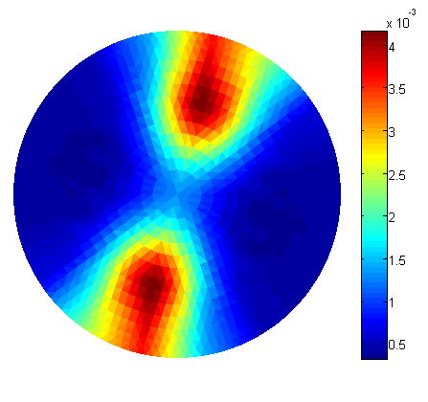
Fig. 3 Reconstructed images

Figure 3 is the situation of two cases by LBP algorithm in sensitive matrix (LBP_s) and in weighting matrix (LBP_w). the target position can be found in each case, but we can see that for all cases, the target position using weighting matrix is more precise.

IV. Conclusion

In this paper, we discussed the weighting matrix as new system model in ECT. This weighting matrix derived for ECT appropriately is revised weighting matrix used for CT. The weighting matrix is derived by using interpolation based on the distance between the centre of element and adjacent EFCLs. In computer simulations, all the evaluations shows that the weighting matrix has better reconstruction performance than the sensitive matrix.

References

[1] Ø. Isaksen, "A review of reconstruction techniques for capacitance tomography," Meas. Sci. Technol., vol.7, no.3, pp.325-337, Mar., 1996.
- W. Q. Yang and L. Peng, "Image reconstruction algorithms for electrical capacitance tomography," Meas. Sci. Technol., vol.14, no.1, pp.R1-13, Jan., 2003.
- C. G. Xie, S. M. Huang, B. S. Hoyle,R. Thorn, C. Lenn, D. Snowden, and M. S. Beck, "Electrical capacitance tomography for flow imaging: system model for development of image reconstruction algorithms and design of primary sensors," IEE Proc.-G, vol.139, no.1, pp.89-98, Feb., 1992.
- Ø. Isaksen, A. S. Dico, and E. A. Hammer, "A capacitance-based tomography system for interface measurement in separation vessels," Meas. Sci. Technol., vol.5, no.10, pp.1262-1271, Oct., 1994.
- J. H. Kim, B. Y. Choi, and K. Y. Kim, "Novel iterative image reconstruction algorithm for electrical capacitance tomography: directional algebraic reconstruction technique," IEICE Trans. Fund., vol.E89-A, no.6, pp.1578-1584, Jun., 2006.
- J. H. Kim, C. Y. Kim, K. Y. Kim, and B. Y. Choi, "Modified directional algebraic reconstruction technique using adjacent current pattern," J. IEEK, vol.49, no.12, pp.256-264, Dec. 2012.
- J. H. Kim, B. S. Kim, C. Y. Kim, K. Y. Kim, and I. S. Lee, "Dynamic Directional Algebraic Reconstruction Technique for Time-Varying Imaging in Electrical Impedance Tomography," J. KIIT, vol.13, no.10, pp.1-8, Oct. 2015.
- X. Dong, Z. Ye, and M. Soleimani, "Image reconstruction for electrical capacitance tomography by using soft-thresholding iterative method with adaptive regulation parameter," Meas. Sci. Technol., vol.24, no.8, pp.085402(8pp), Jul., 2013.
- L. Peng, H. Merkus, and B. Scarlett, "Using regularization methods for image reconstruction of electrical capacitance tomography," Part. Part. Syst. Charact., vol. 17, no. 3, pp. 96-104, 2000.

